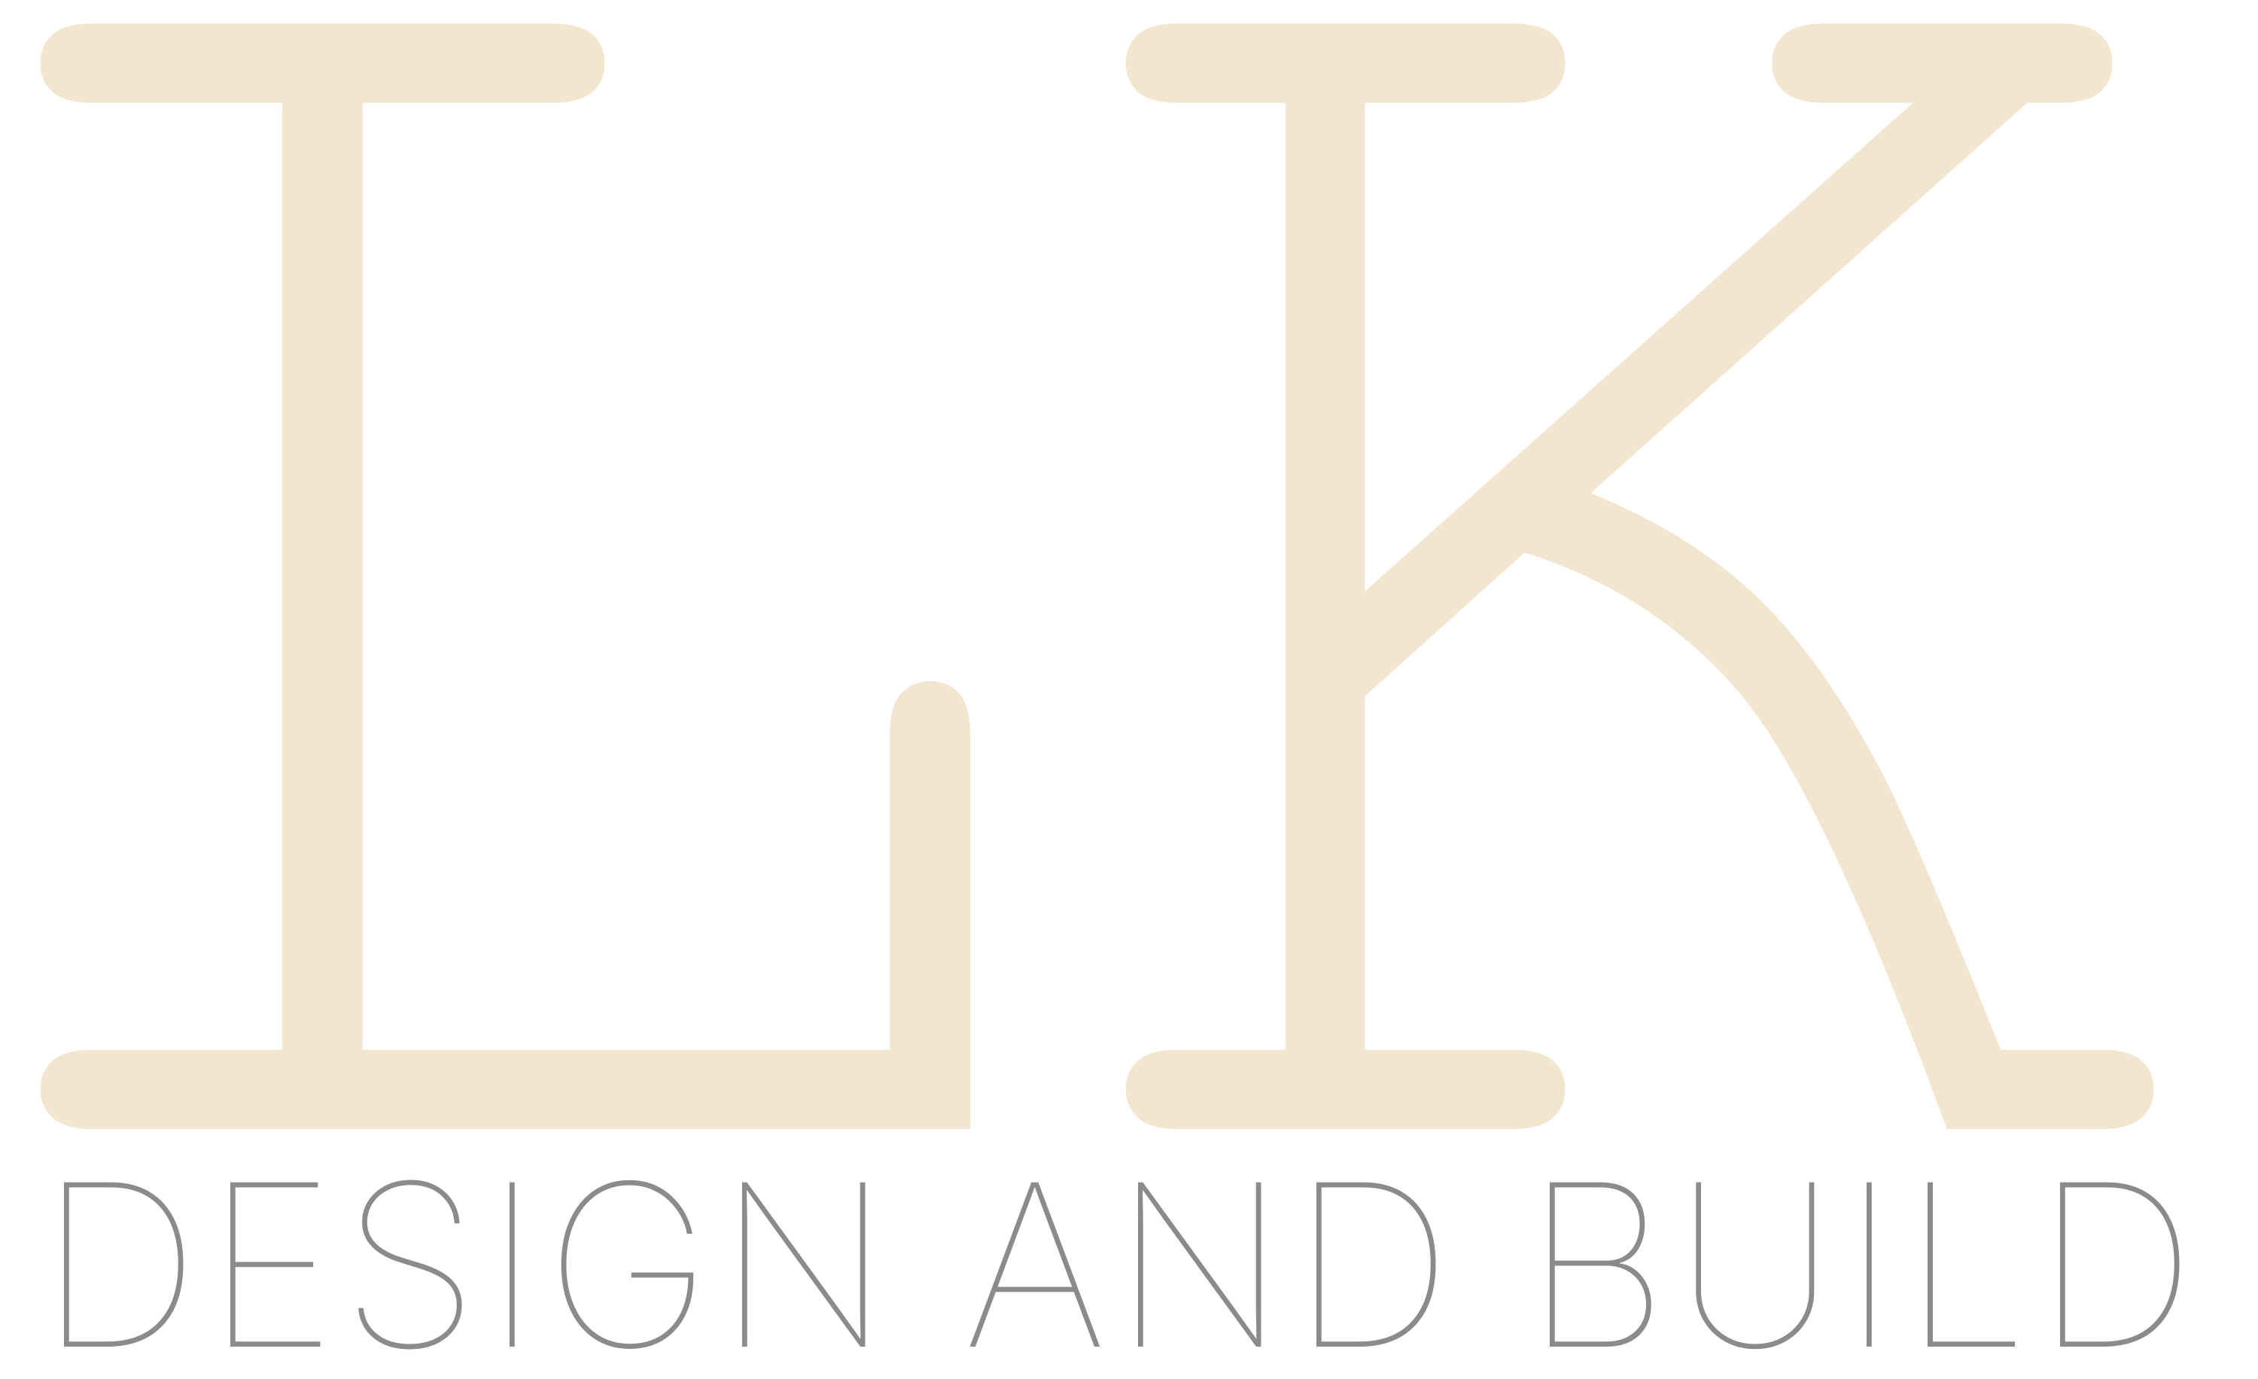

0401 061 246 | lyda@lkdesignandbuild.com.au | www.lkdesignandbuild.com.au | PO Box 867 Prospect East SA 5082

[Date]
[Recipient Name]
[Company / Address Line 1]
[Address Line 2]
[City, State, Postcode]

Re: [Subject Line]
Dear [Name],
Thank you for your interest in LK Design and Build. We specialise in premium home renovations, additions, and new builds across Adelaide, delivering exceptional craftsmanship and thoughtful design at every stage.
[Continue your letter here. This template provides the branded letterhead with the approved LK — Courier Slab logo. Simply replace the placeholder text with your content.]
We look forward to discussing your project in detail.

Kind regards,

Lyda
LK Design and Build

LK Design and Build | ABN 17 697 207 391 | Considered design. Precision build.

