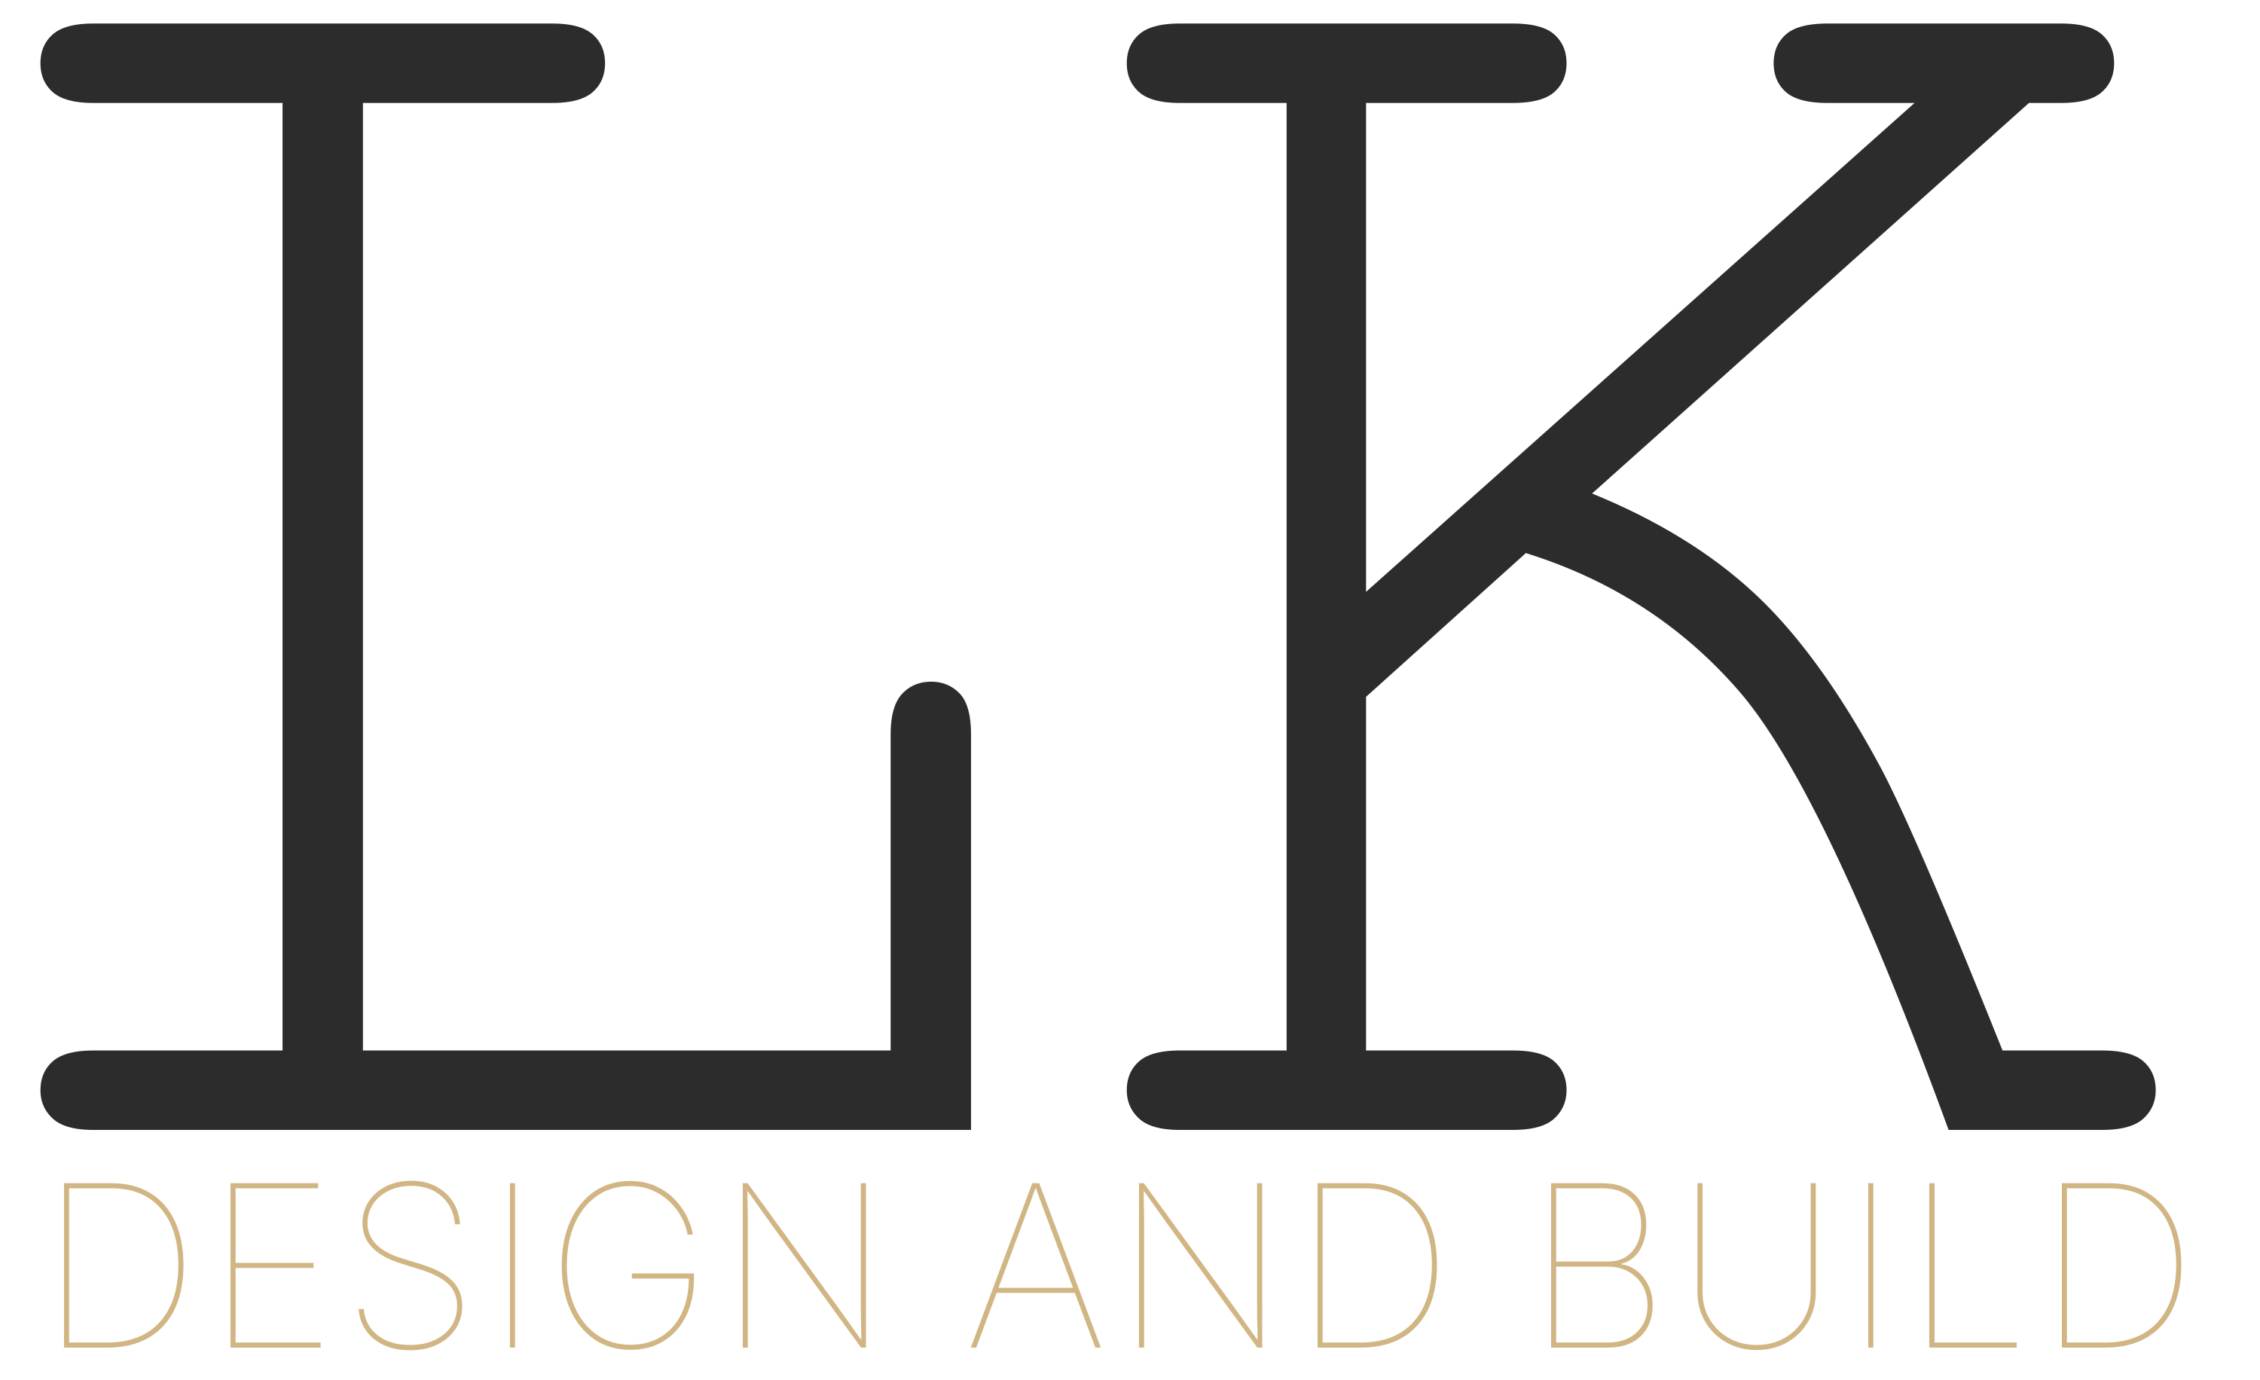

0401 061 246 | lyda@lkdesignandbuild.com.au | www.lkdesignandbuild.com.au | PO Box 867 Prospect East SA 5082

QUOTATION

Quote Number: | [QTE-0001]
Date: | [Date]
Valid Until: | [Date + 30 days]
Project Address: | [Site Address]

PREPARED FOR
[Client Name]
[Client Address]
[Client Email]
[Client Phone]

SCOPE OF WORKS
[Describe proposed works, demolition, structural, finishes, fixtures, allowances.]
Description | Qty | Amount (ex GST)
[Demolition & Site Preparation] | 1 | $X,XXX.XX
[Structural Works] | 1 | $X,XXX.XX
[Carpentry & Framing] | 1 | $X,XXX.XX
[Electrical] | 1 | $X,XXX.XX
[Plumbing] | 1 | $X,XXX.XX
[Tiling & Waterproofing] | 1 | $X,XXX.XX
[Joinery & Cabinetry] | 1 | $X,XXX.XX
[Painting & Finishes] | 1 | $X,XXX.XX
[Fixtures & Fittings — Allowance] | 1 | $X,XXX.XX
[Project Management & Supervision] | 1 | $X,XXX.XX

Subtotal (ex GST): $XX,XXX.XX
GST (10%): $X,XXX.XX
TOTAL (inc GST): $XX,XXX.XX

TERMS & CONDITIONS
1. This quotation is valid for 30 days from the date of issue.
2. A 10% deposit is required upon acceptance to secure scheduling.
3. Progress payments are due at agreed milestones as outlined in the building contract.
4. All works are carried out in accordance with the Building Code of Australia and relevant South Australian regulations.
5. Any variations to the scope of works will be documented and agreed in writing before commencement.
6. LK Design and Build holds comprehensive public liability and construction insurance.
7. Defects liability period: 12 months from practical completion.

ACCEPTANCE
I/We accept this quotation and the terms and conditions outlined above.

Client Signature: ___________________________ | Date: ___________________________
Print Name: ___________________________

LK Design and Build | ABN 17 697 207 391 | Considered design. Precision build.

